Generate Bear Images using Variational Autoencoders (VAEs)
Variational Autoencoders (VAEs) are a type of generative model particularly suited for image editing through concept vectors. They are an evolution of autoencoders, which are designed to compress input data into a lower-dimensional latent space and then reconstruct it. The unique feature of VAEs is that they regularize the distribution of their encodings during training. This ensures that their latent space is structured in a manner that facilitates the generation of new samples.
As a specialist in deep learning, you are tasked with crafting a Python program leveraging the TensorFlow library. Your goal is to construct a Variational Autoencoders (VAEs) model in line with the subsequent criteria:
- Load and Split Dataset
  - Load Dataset
In this section, you are required to:
    - Assign the dataset path to the previously declared PATH variable.
    - Load the image from the given dataset into an array using RGB as the color mode.
    - Randomly shuffle the dataset.
  - Split Dataset
You are tasked to split the given dataset into 2 main parts which are training and testing sets with the proportion of 80/20.
- Data Preprocessing
You are tasked with reshaping the given dataset, which includes the training, validation, and testing sets, by converting the data type to float32. Following this, you will need to normalize the dataset, comprising the training, validation, and testing sets, by dividing the values of all image pixels by 255.

- Variational Autoencoders Architecture (Model Architecture Visualization, Initialization, and Configuration)
  - Model Visualization
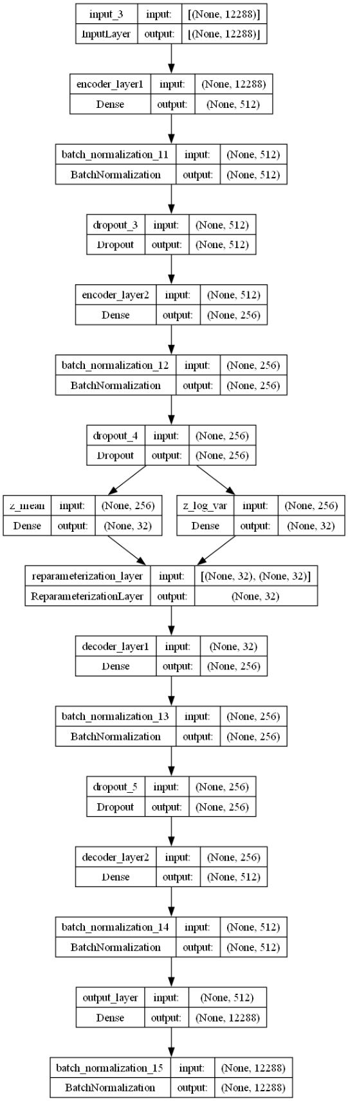
Figure 1. Model Visualization (Fully Connected)
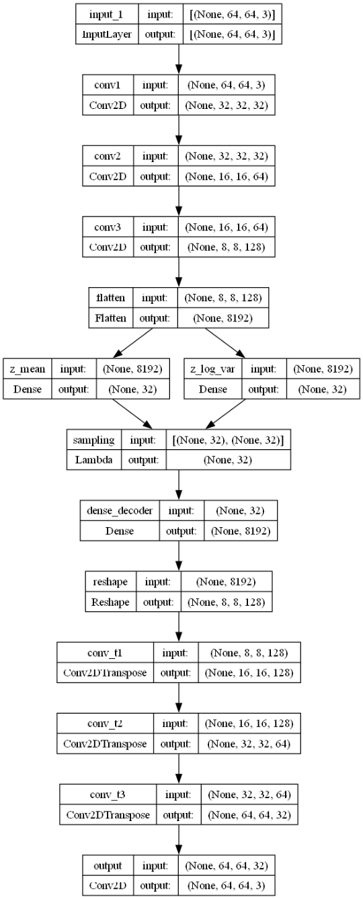
Figure 2. Model Visualization (Convolutional)
  - Model Initialization and Configuration – Encoder
Input Layer: This takes the data (like an image) as input.
Hidden Layers: One or more layers that transform the input data. These can be fully connected layers, convolutional layers, or any other type of layer suitable for the data type. You are free to use different architectures. (Fully connected or convolutional)
Output Layer: Produces two vectors for each input data point: a mean vector $\left(μ\right)$ and a log variance vector $\left(\log\left(σ^{2}\right)\right)$.
These vectors are used to parameterize the Gaussian distribution from which we’ll sample the latent variable ‘z’.
  - Model Initialization and Configuration – Latent Space
This is a lower-dimensional space where we encode our data. A point ‘z’ in this space is sampled from the Gaussian distribution parameterized by $μ$ and $\log\left(σ^{2}\right)$ from the encoder. The reparameterization trick is used here to make this sampling process differentiable. Instead of directly sampling from the distribution, we sample from a standard normal distribution and then scale and shift using µ and σ. The formula for the reparameterization trick is $z=μ+σ⊙ϵ$, where μ is the mean vector produced by the encoder, σ is the standard deviation, and ϵ is a random noise sampled from a standard normal distribution.
  - Model Initialization and Configuration – Decoder
Input Layer: Takes the sampled ‘z’ from the latent space.
Hidden Layers: One or more layers that transform the latent variable back towards the original data’s dimensionality.
Output Layer: Produces the reconstructed data, ideally as close to the original input data as possible.
- Model Training
You are tasked with training the model that you previously constructed. Utilize the Adam optimizer and select the appropriate loss function based on the specifics of your case. Monitor the performance using reconstruction loss and KL Divergence as the metric. Ensure that the training process spans a minimum of 50 epochs. You have the flexibility to set the batch size and learning rate for the optimizer according to your judgment.
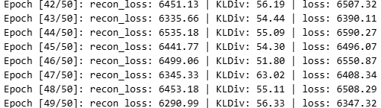
Figure 3. Model Training
- Predicting Data Using Created Model and Model Evaluation
You are tasked with evaluating the testing sets using the model that you previously constructed. Display both the original and the reconstructed images, showcasing 10 images each.
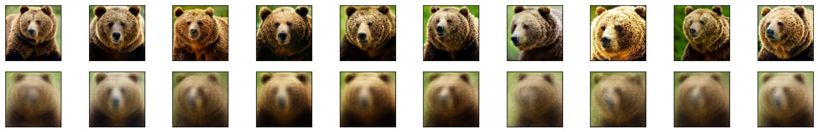
Figure 4. Original Images and Reconstructed Images

